NAME: HARSHINI P R REG NO: 192524165
COURSE CODE: CSA0603 COURSE NAME: DAA

LAB PROGRAMS SESSION – 3

1. def paths(m, n, N, i, j):
if i < 0 or j < 0 or i >= m or j >= n:
return 1
if N == 0:
return 0

return (paths(m, n, N-1, i+1, j) +
paths(m, n, N-1, i-1, j) +
paths(m, n, N-1, i, j+1) +
paths(m, n, N-1, i, j-1))
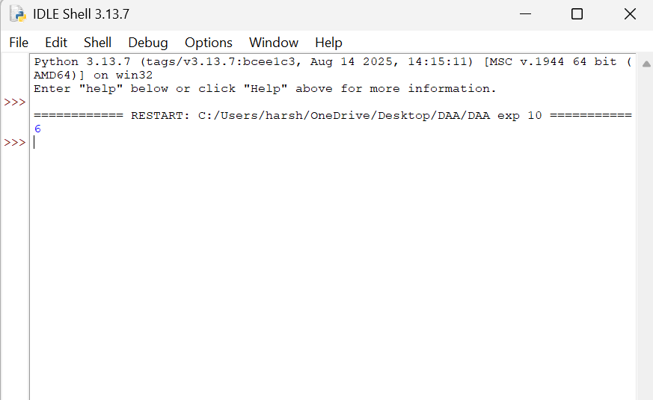
print(paths(2, 2, 2, 0, 0))

2. def rob(nums):
if len(nums) == 1:
return nums[0]

def maximum(a):
x = y = 0
for n in a:
x, y = y, max(y, x + n)
return y

return max(maximum(nums[:-1]), maximum(nums[1:]))

print(rob([2, 3, 2]))
print(rob([1, 2, 3, 1]))

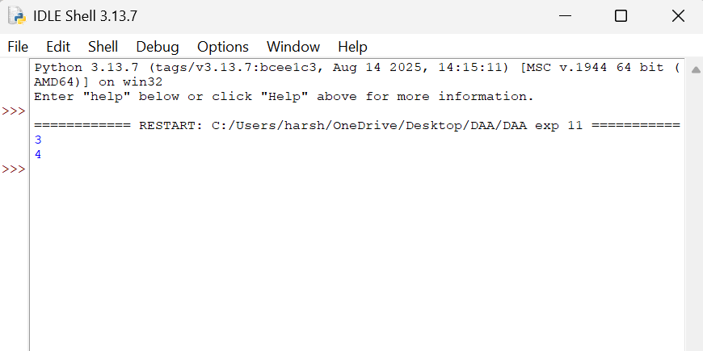

3. def climb(n):
a, b = 1, 1
for i in range(n - 1):
a, b = b, a + b
return b

print(climb(4))
print(climb(3))

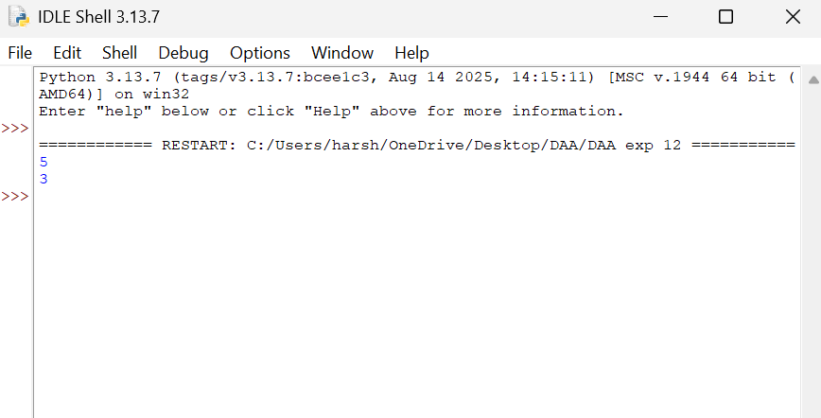

4. def paths(m, n):
dp = [[1] * n for i in range(m)]

for i in range(1, m):
for j in range(1, n):
dp[i][j] = dp[i-1][j] + dp[i][j-1]

return dp[m-1][n-1]

print(paths(7, 3))
print(paths(3, 2))

